User Management microservice project is created in .Net 9 with Domain-Driven Design. The project structure is below

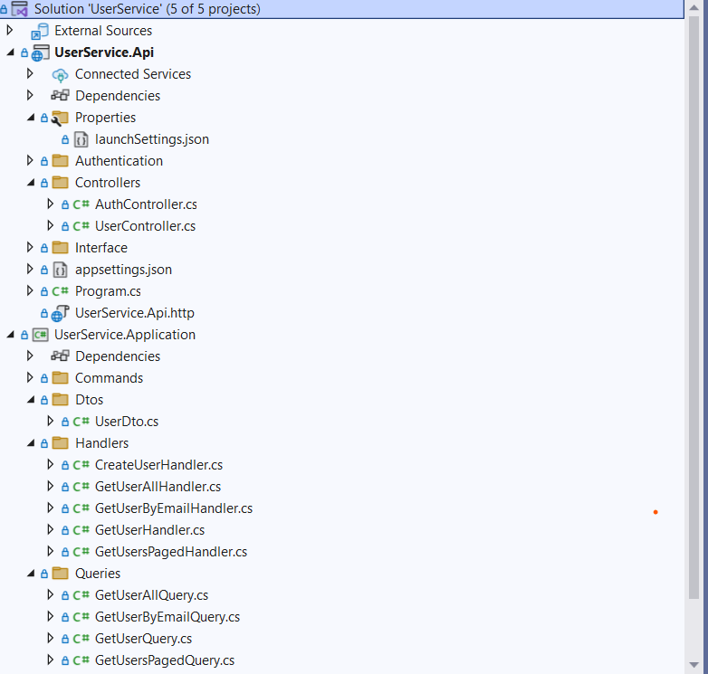

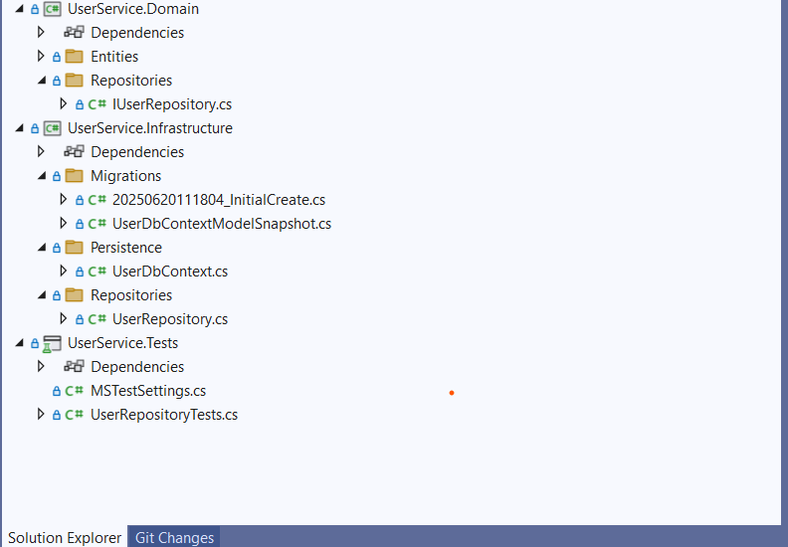

Entity framework Execution

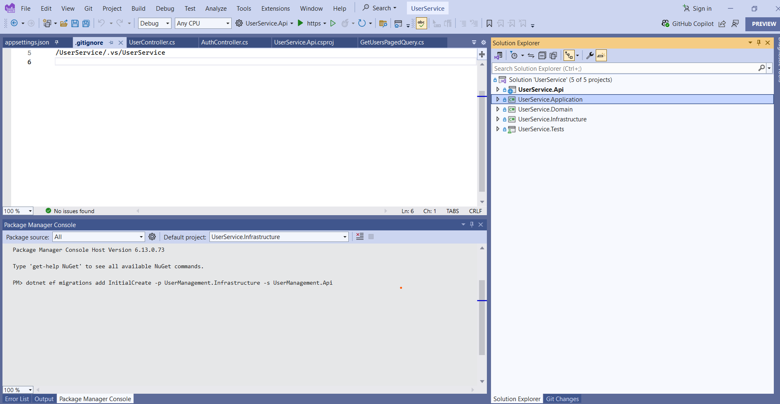

Create migrations in UserManagement.Infrastructure and apply

dotnet ef migrations add InitialCreate -p UserManagement.Infrastructure -s UserManagement.Api

dotnet ef database update -p UserManagement.Infrastructure -s UserManagement.Api

Database

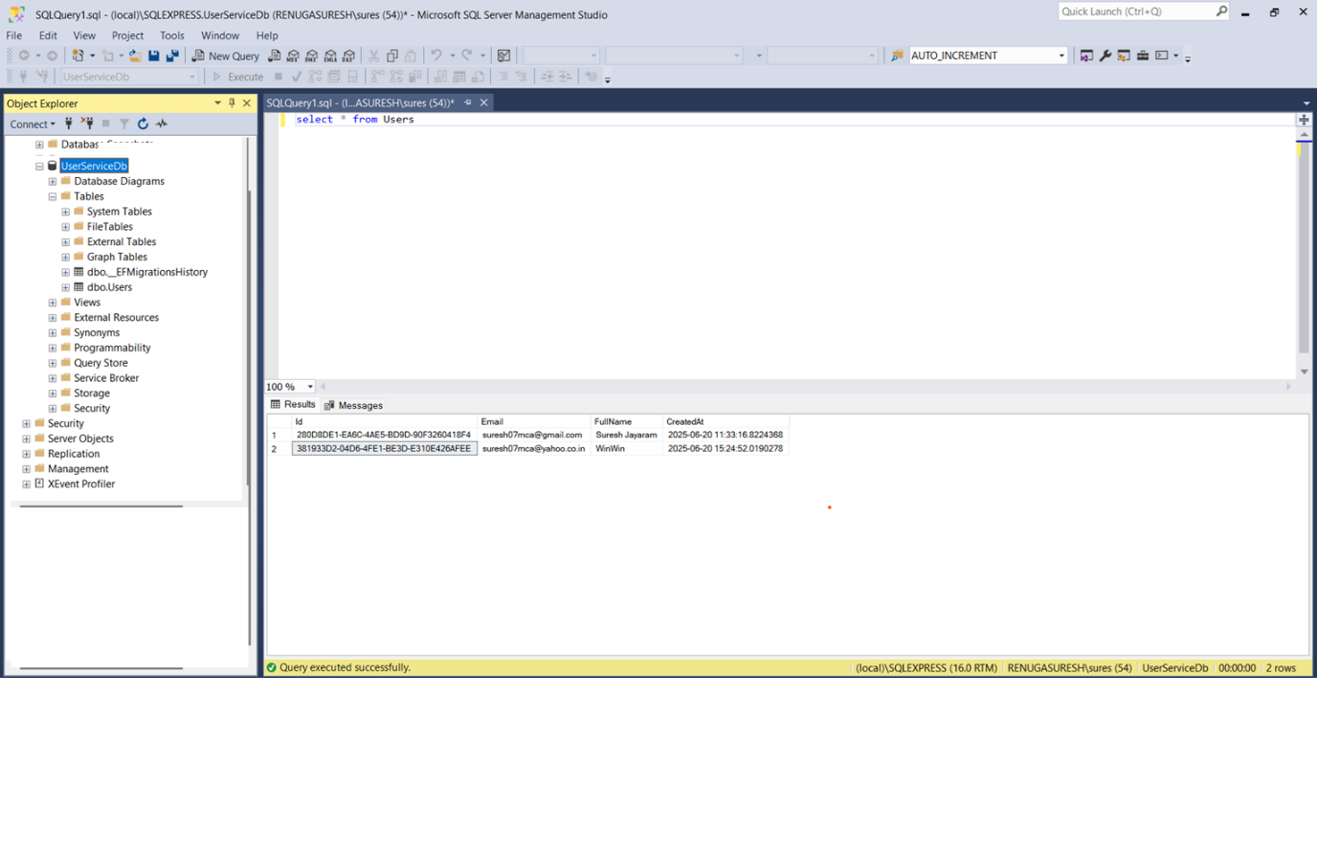

Run the API

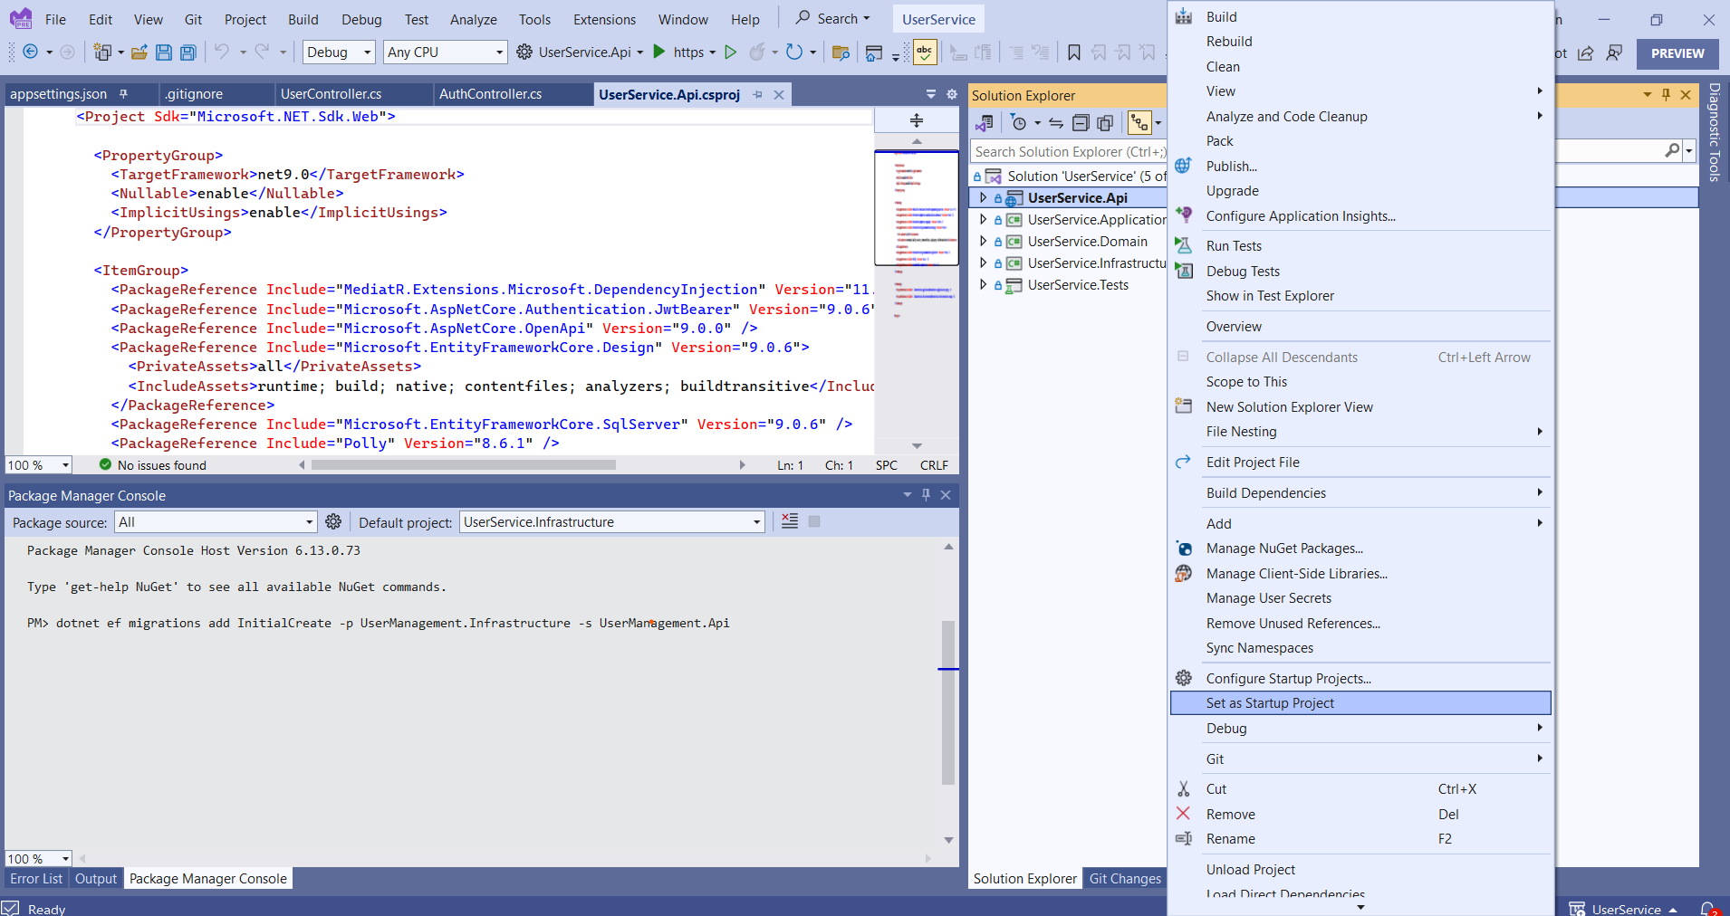

Click on Run

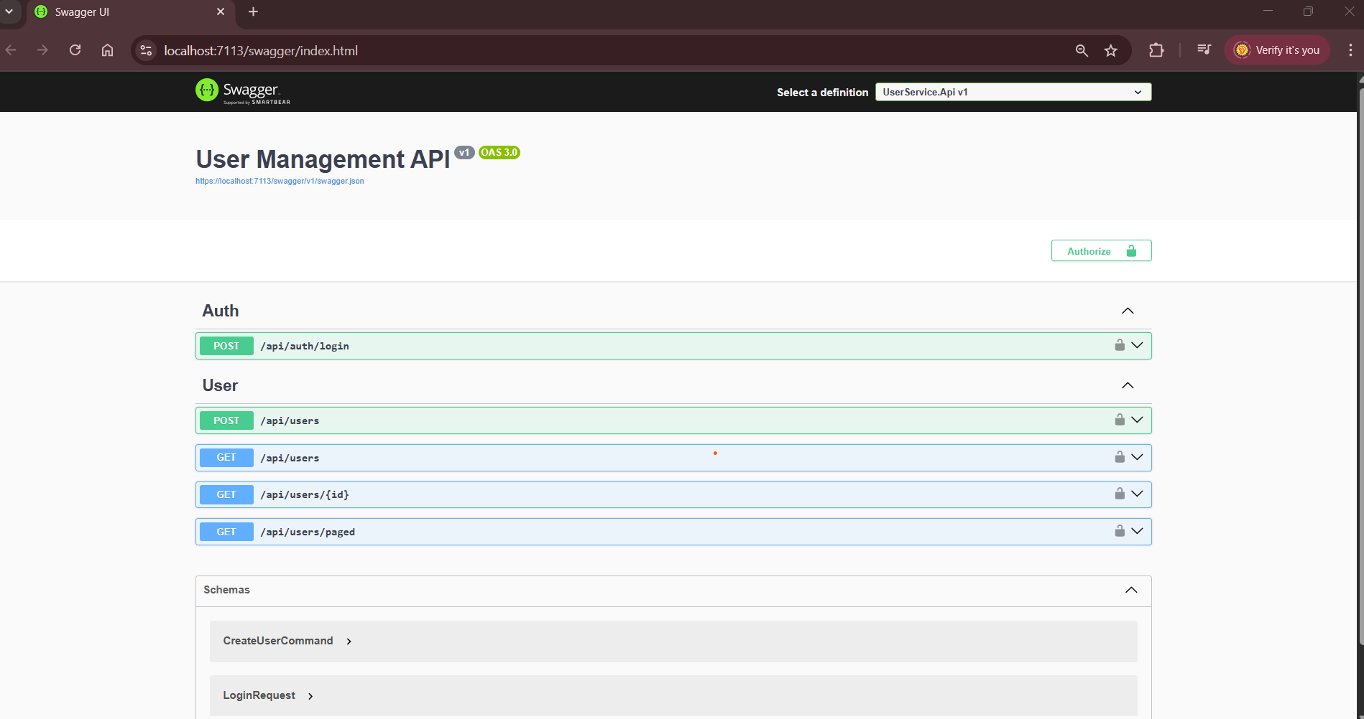

Execute the Login APPI

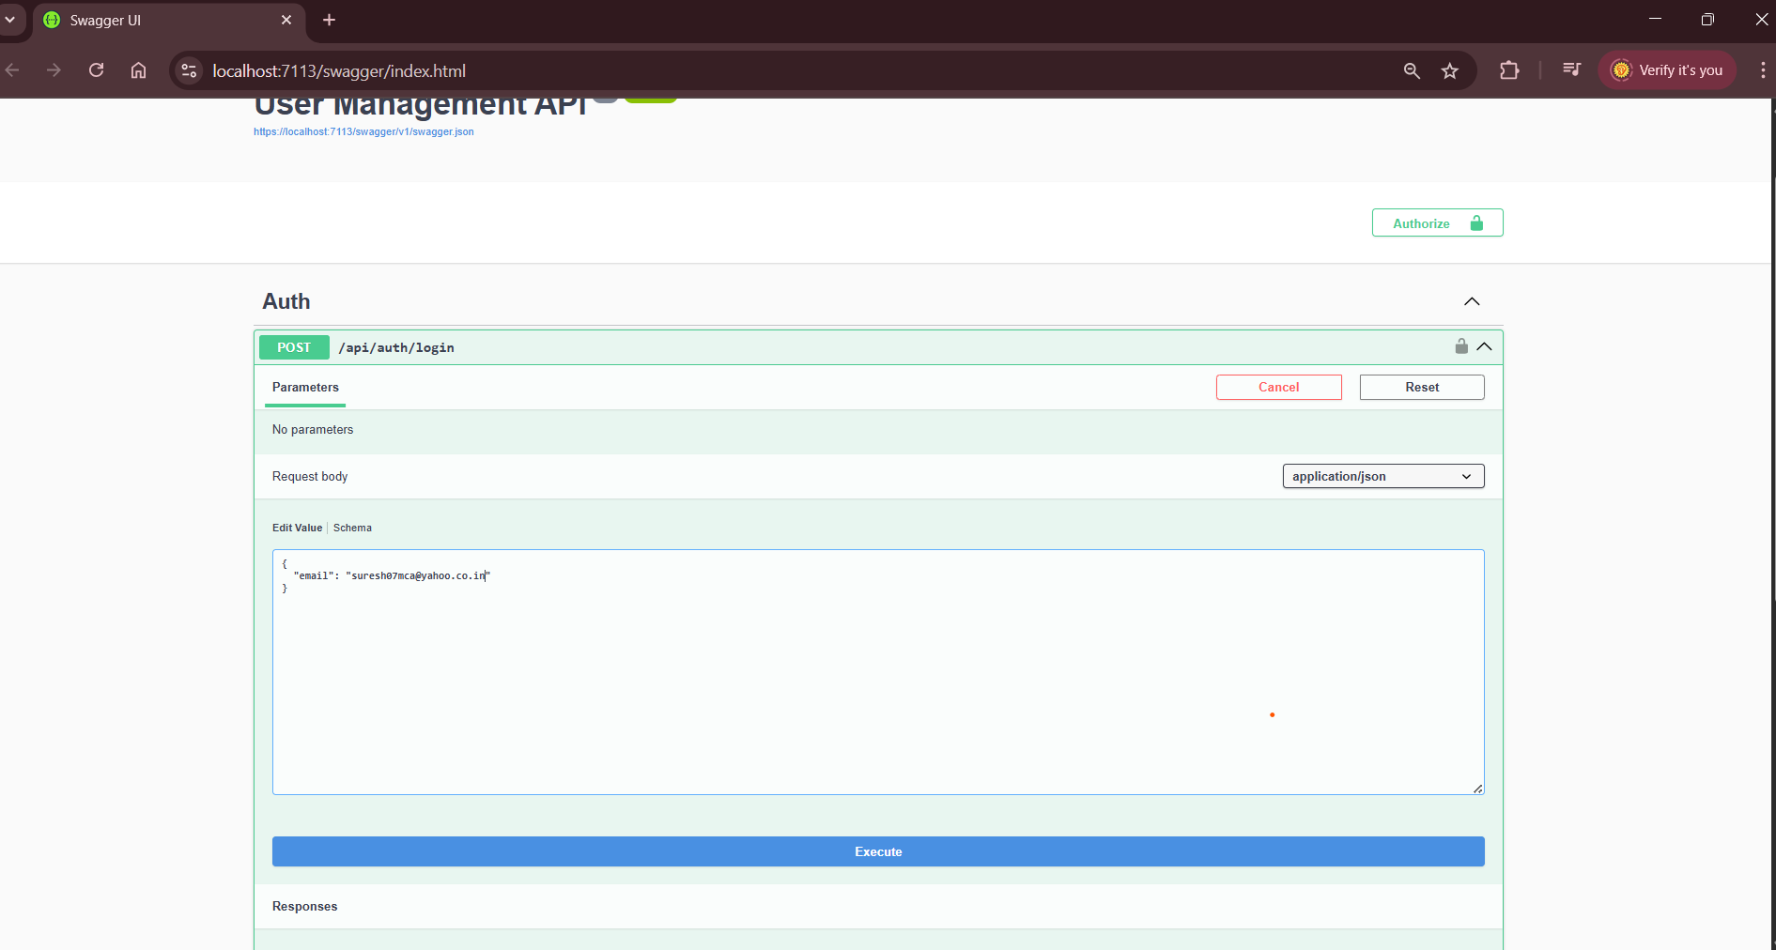

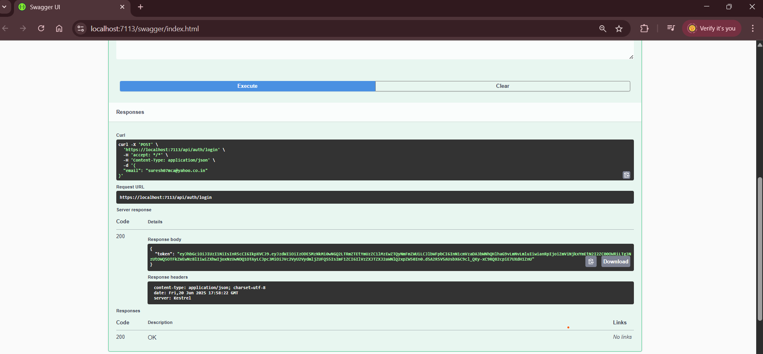

Copy the token and Click on Authorize Button in top right side

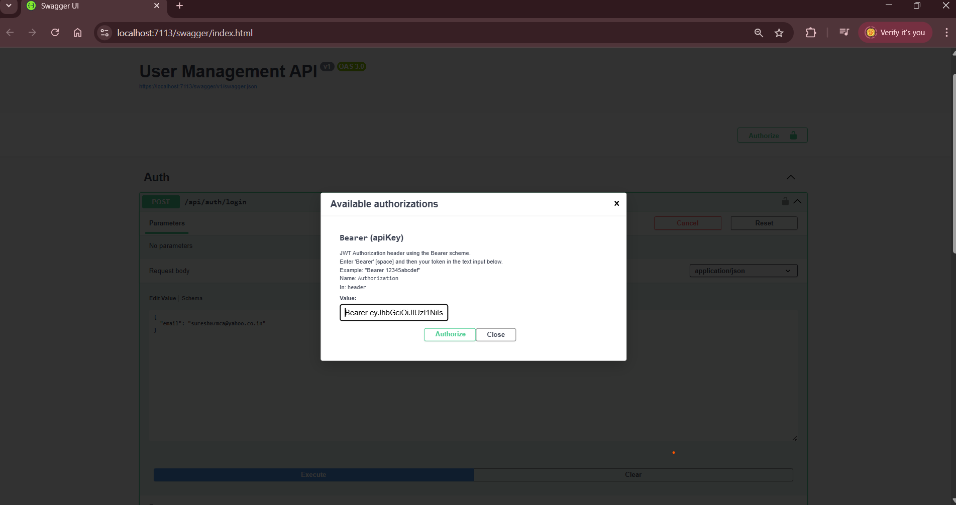

Click on authorize button

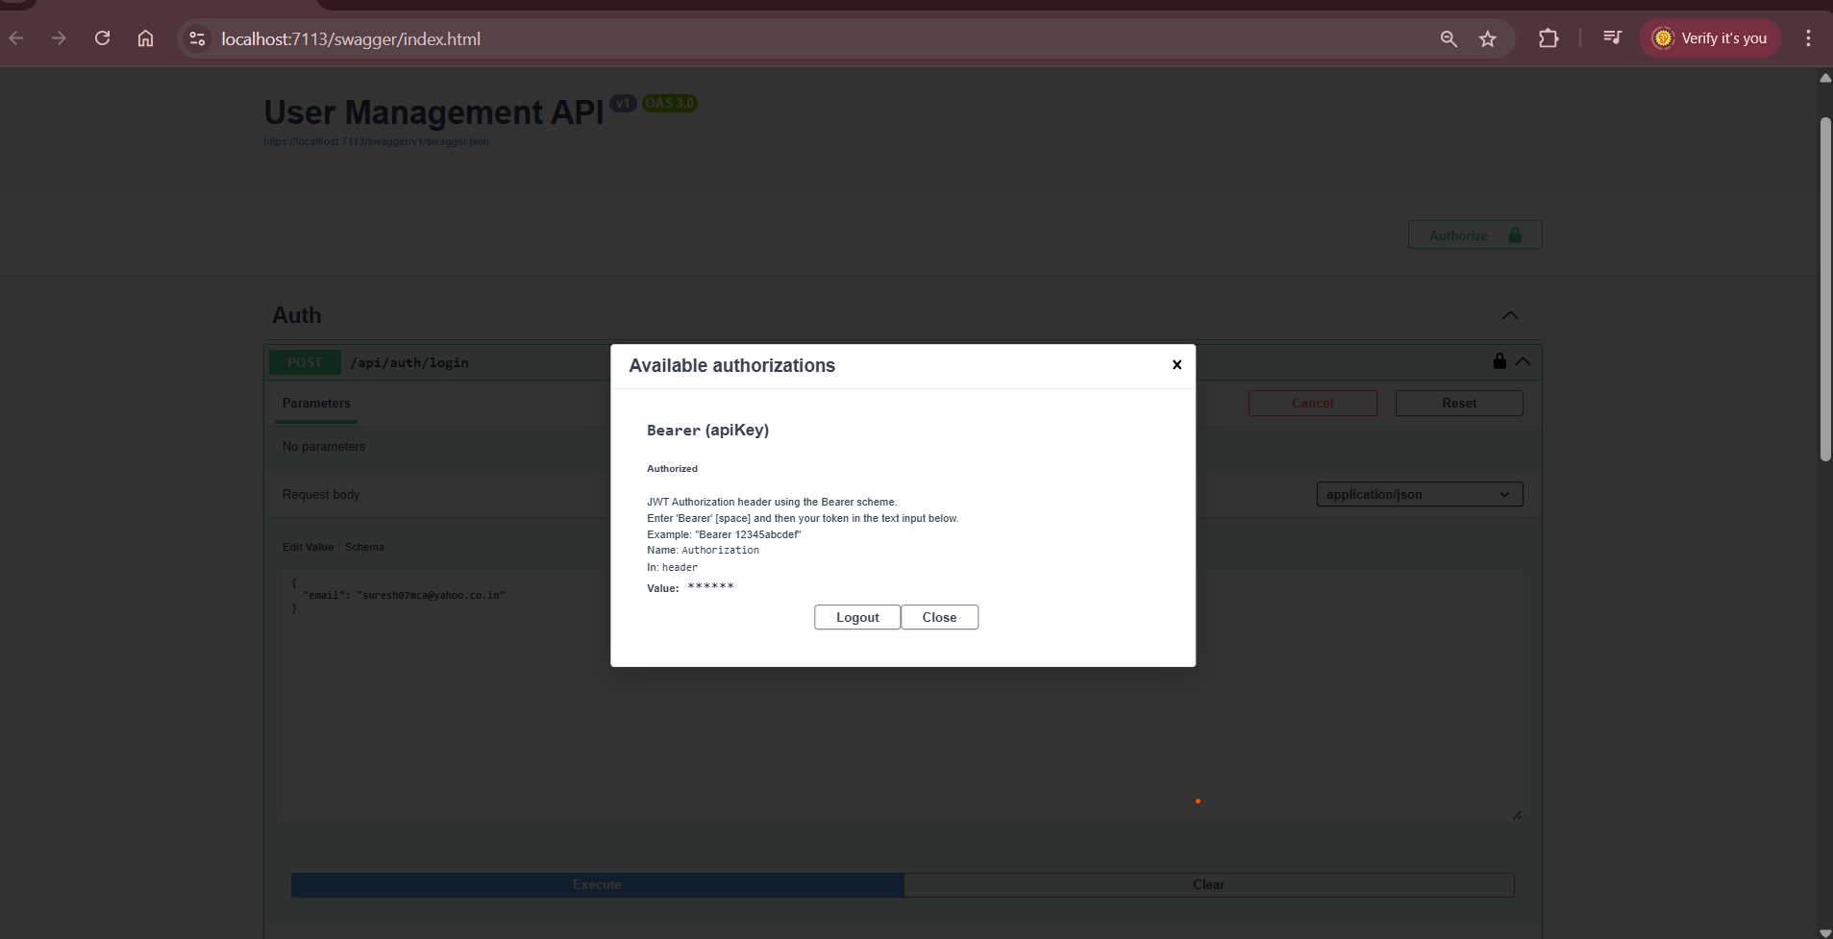

Click on close

Execute any api for example Add User

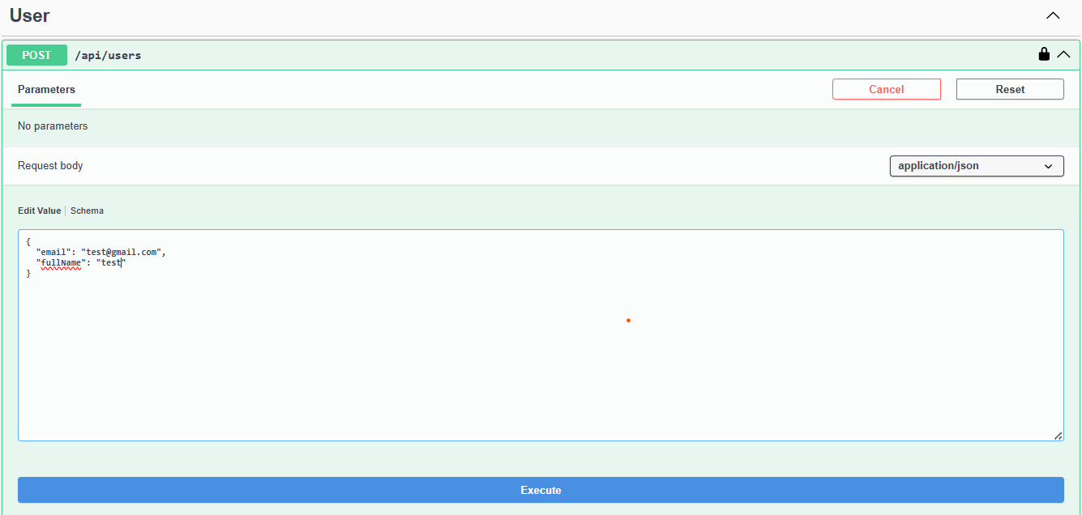

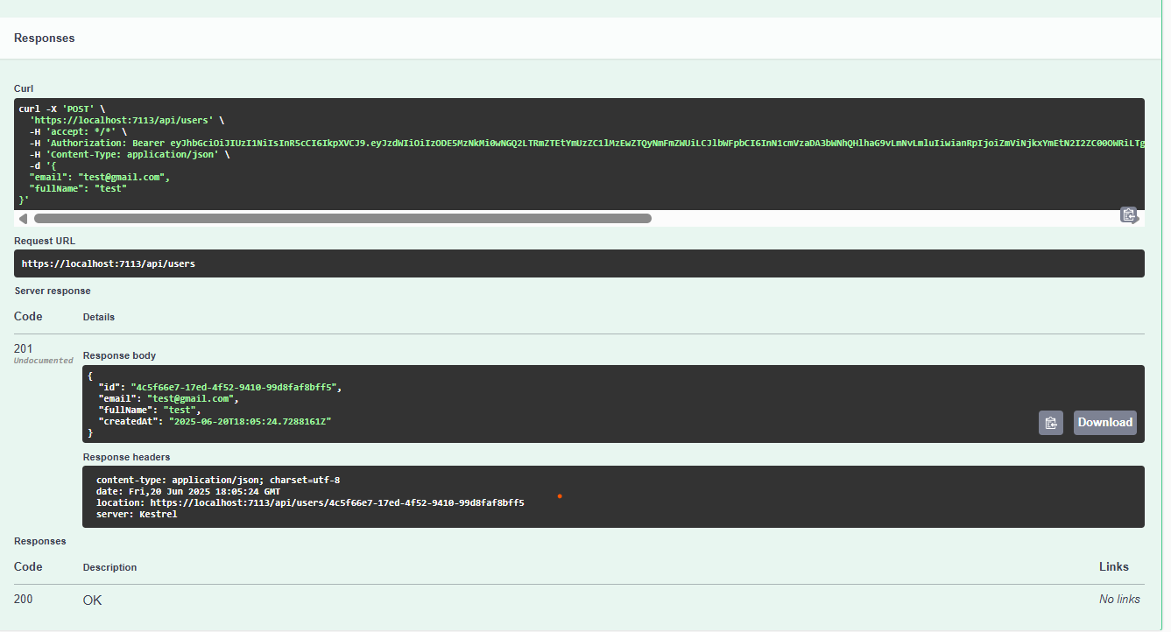

Get All User

